Lab Setup - Initial Shipment
You should expect to receive the following equipment in the coming days. Upon arrival, we request that you please:
- Verify receipt of these items in the quantities specified
- Check items for any damages during shipment
- Confirm receipt, quantities & condition to us at support@floodlamp.bio
Please do not unpack items beyond inspecting for damage during shipment - leave these items in their packaging until lab setup (because you will be cleaning them as you set up).

Description | Qty. | Received? | Expected Arrival Date | Notes
Mini Centrifuge  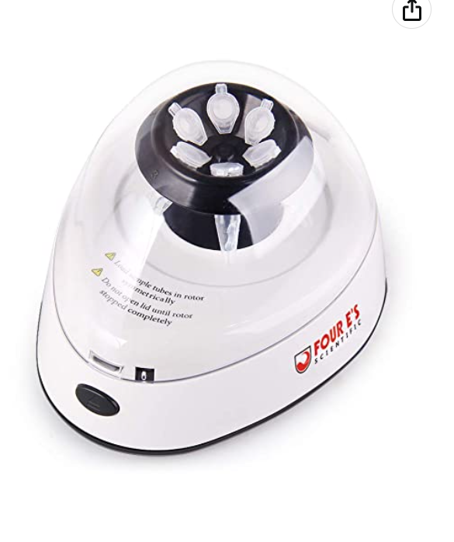 | 1
Vortexer  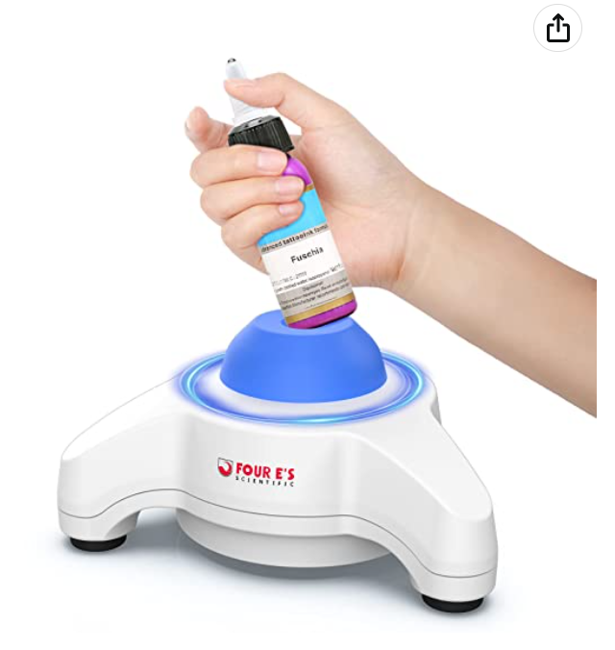 | 2 |  |  | 1 blue, 1 red
Wireless Temp Sensor  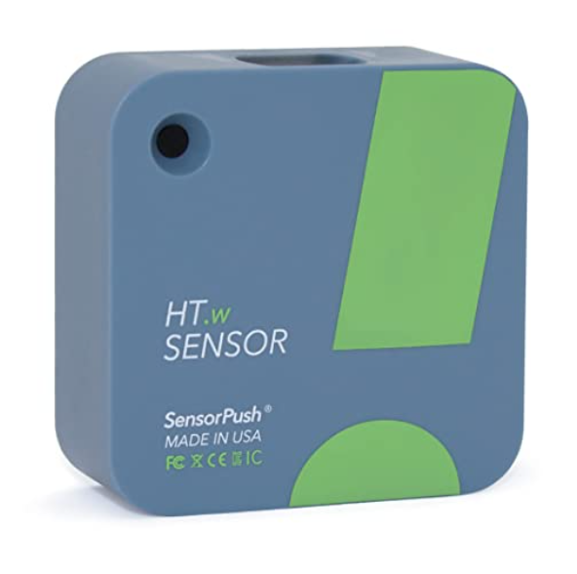 | 1
Wireless Sensor Gateway  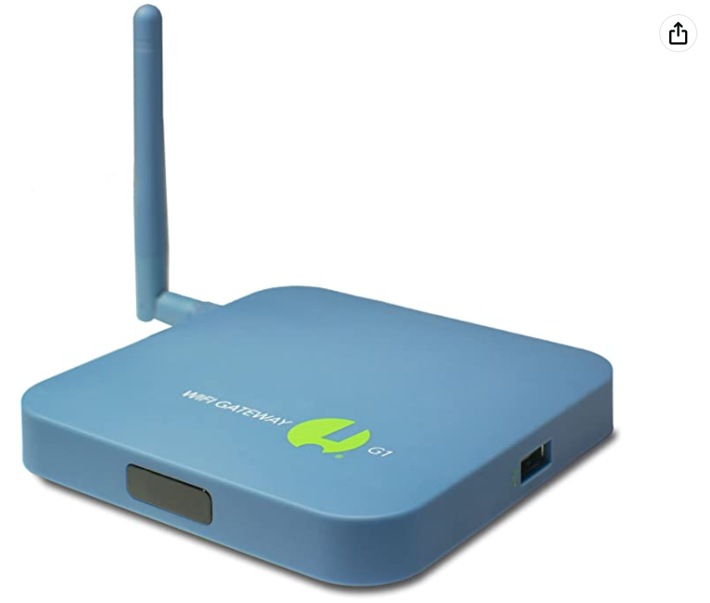 | 1
Water Bath  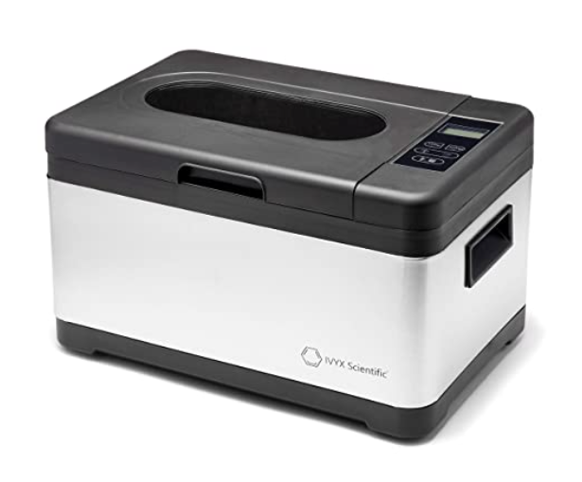 | 1

Description | Qty. | Received? | Expected Arrival Date | Notes
Light Box  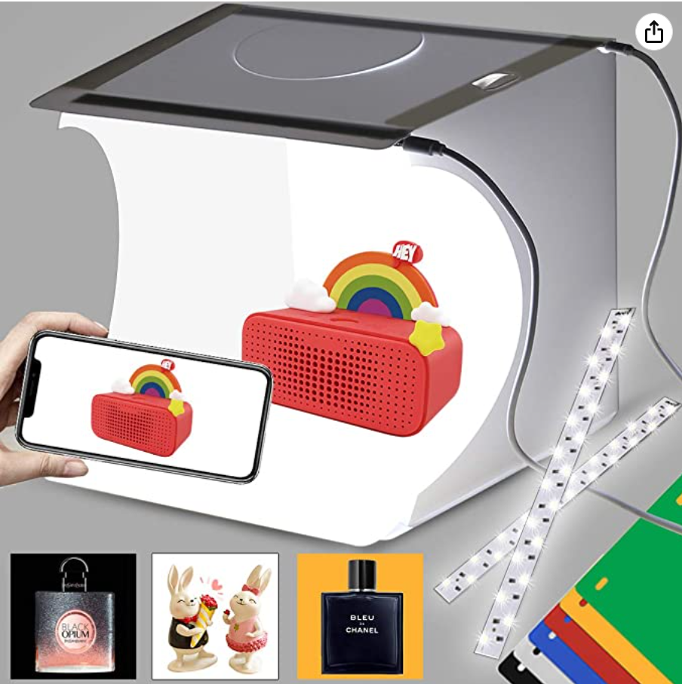 | 1
250mL Saline  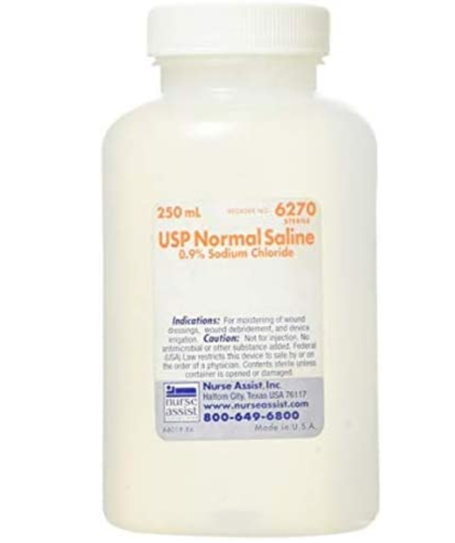 | 6
Freezer | 1
Cart | 1
Eyewash Station  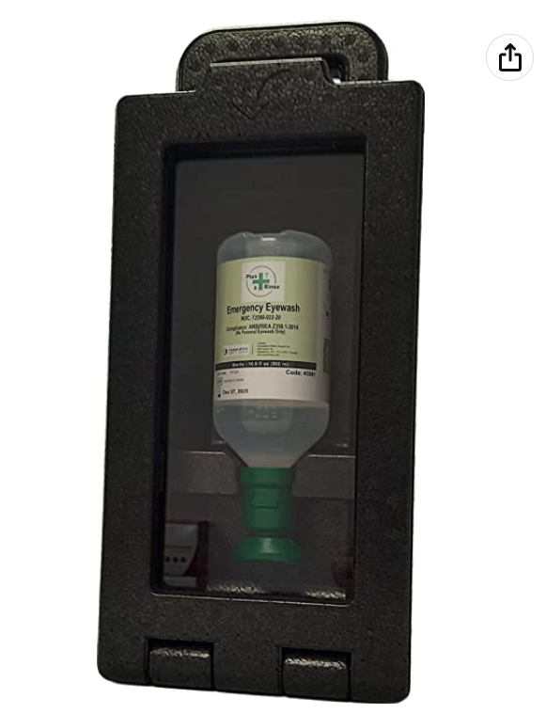 | 1
Air Purifier  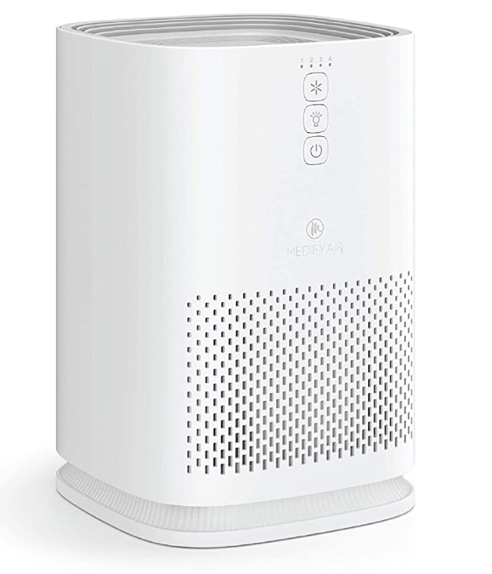 | 1
Fridge | 1

